Structural Grammar

🔹 What is Structural Grammar
# Source: Chatgpt (GPT-4-turbo) at [8/3/2025]
Structural grammar (or structuralist grammar) is a linguistic approach that analyzes language as a system of interrelated structures. It focuses on how words function within sentence patterns rather than their meanings alone.
This type of grammar was developed primarily in the early 20th century by linguists such as Leonard Bloomfield.

✅ Key Features of Structural Grammar:
# Source: Chatgpt (GPT-4-turbo) at [8/3/2025]
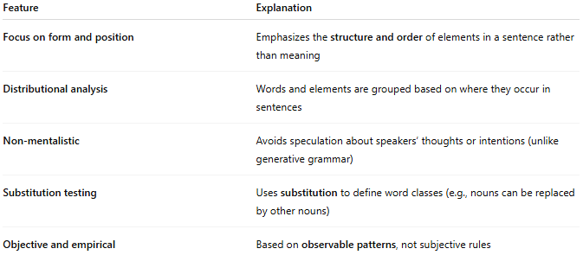
Feature | Explanation
Focus on form and position | Emphasizes the structure and order of elements in a sentence rather than meaning
Distributional analysis | Words and elements are grouped based on where they occur in sentences
Non-mentalistic | Avoids speculation about speakers’ thoughts or intentions (unlike generative grammar)
Substitution testing | Uses substitution to define word classes (e.g., nouns can be replaced by other nouns)
Objective and empirical | Based on observable patterns, not subjective rules

✅ Core Concepts in Structural Grammar:
# Source: Chatgpt (GPT-4-turbo) at [8/3/2025]
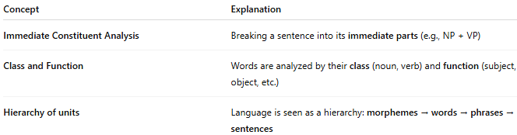
Concept | Explanation
Immediate Constituent Analysis | Breaking a sentence into its immediate parts (e.g., NP + VP)
Class and Function | Words are analyzed by their class (noun, verb) and function (subject, object, etc.)
Hierarchy of units | Language is seen as a hierarchy: morphemes → words → phrases → sentences

✅ Examples of Structural Analysis:
# Source: Chatgpt (GPT-4-turbo) at [8/3/2025]
Take the sentence:
"The cat sat on the mat."
- Immediate constituents:
  - [NP: The cat] + [VP: sat on the mat]
- Further breakdown:
  - NP → Det (The) + Noun (cat)
  - VP → Verb (sat) + PP (on the mat)
  - PP → Prep (on) + NP (the mat)
Each part is defined not by meaning, but by its position and behavior in the sentence.

✅ Structural Grammar vs. Other Types:
# Source: Chatgpt (GPT-4-turbo) at [8/3/2025]
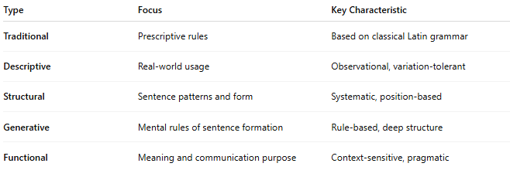
Type | Focus | Key Characteristic
Traditional | Prescriptive rules | Based on classical Latin grammar
Descriptive | Real-world usage | Observational, variation-tolerant
Structural | Sentence patterns and form | Systematic, position-based
Generative | Mental rules of sentence formation | Rule-based, deep structure
Functional | Meaning and communication purpose | Context-sensitive, pragmatic

✅ Why Structural Grammar Matters:
# Source: Chatgpt (GPT-4-turbo) at [8/3/2025]
- Provides a scientific method to analyze sentence structure
- Useful in language teaching, language comparison, and syntax modeling
- Forms a bridge between traditional grammar and modern linguistic theories
- Basis for phrase structure grammar and early syntax trees

📝 Summary:
# Source: Chatgpt (GPT-4-turbo) at [8/3/2025]
- Structural grammar analyzes how elements of a sentence are arranged and related.
- Focuses on form, position, and pattern, not meaning or mental processes.
- Developed by structural linguists like Leonard Bloomfield.
- Precursor to more advanced frameworks like generative grammar.

